**React E-commerce Application Deployment – Screenshots**

**GitHub Repo URL**

* <https://github.com/keerthana-v184/devops-build.git>

**GitHub – main branch**

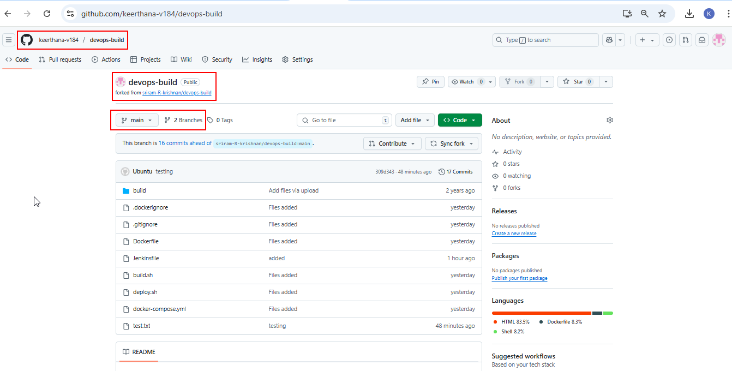

**GitHub – dev branch**

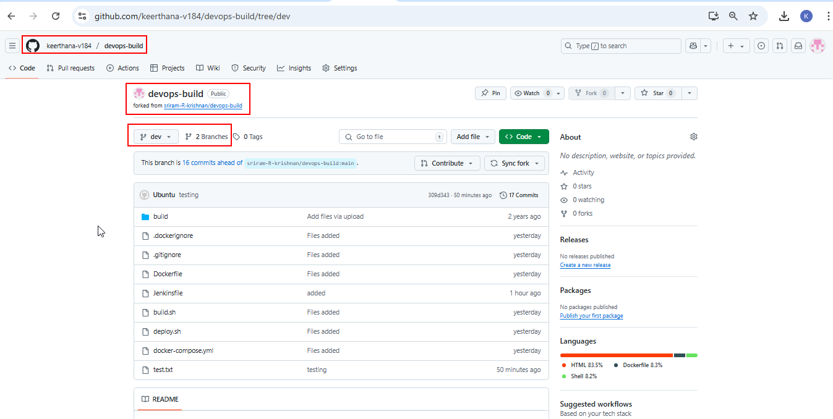

**Deployed site URL**

* React Application deployed site URL - <http://35.173.187.48>

**Docker Images:**

* Public Repo – iamkeerthana/dev:dev
* Private Repo – iamkeerthana/prod:prod

**Jenkins - Login page:**

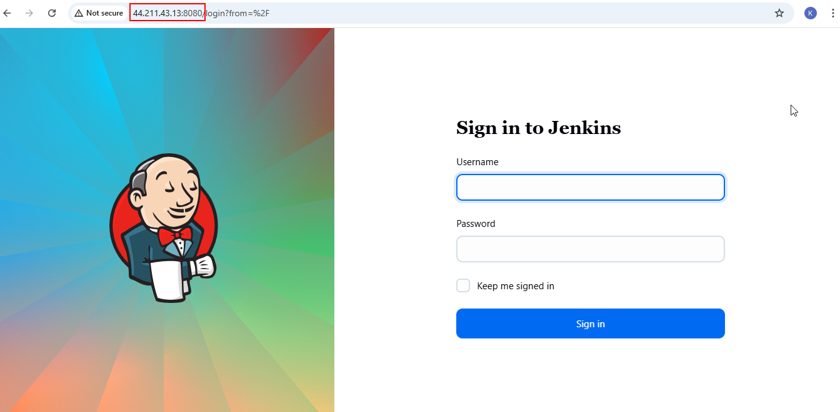

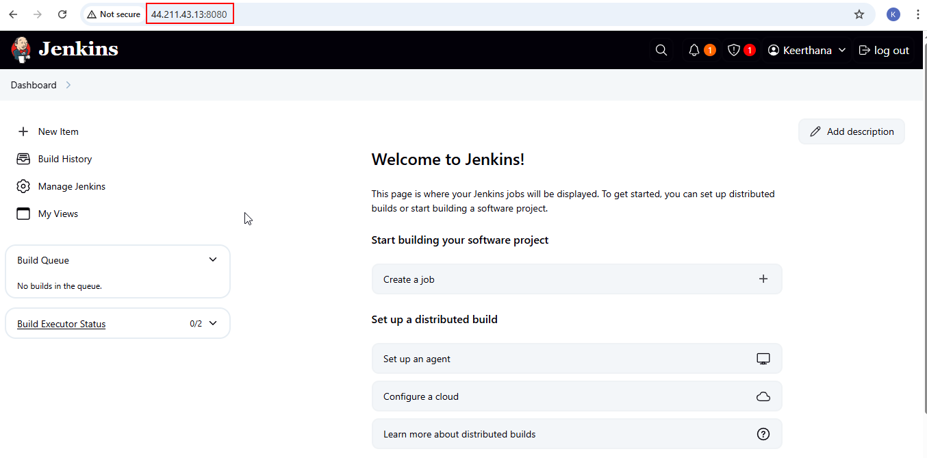

**Jenkins - Configuration settings:**

**Credentials configuration:**

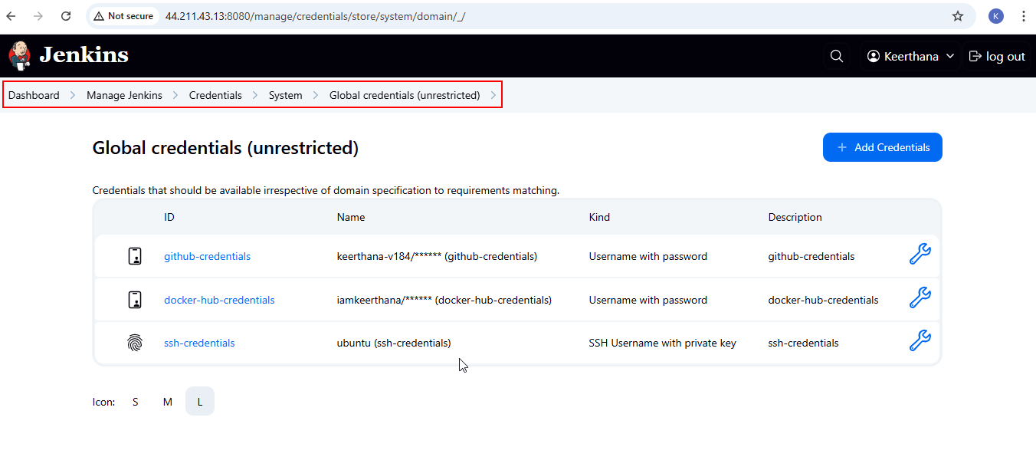

**Pipeline Configuration:**

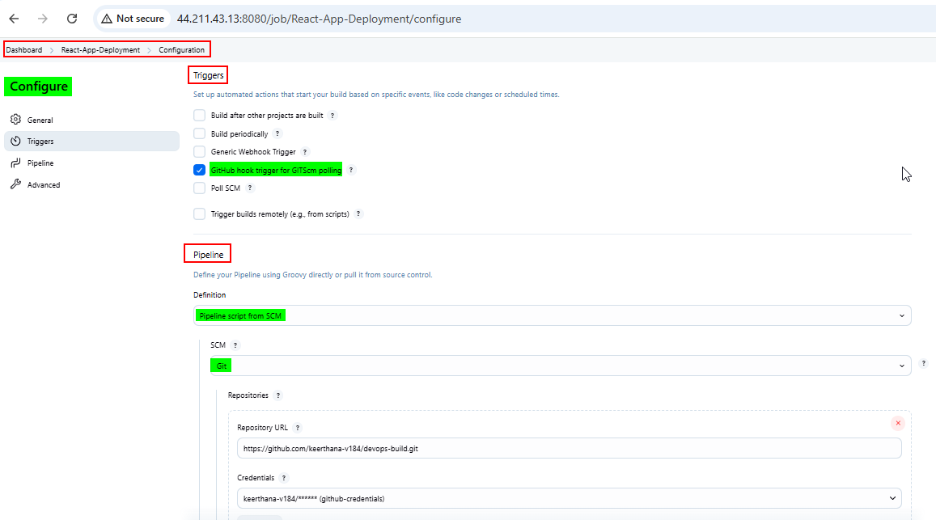

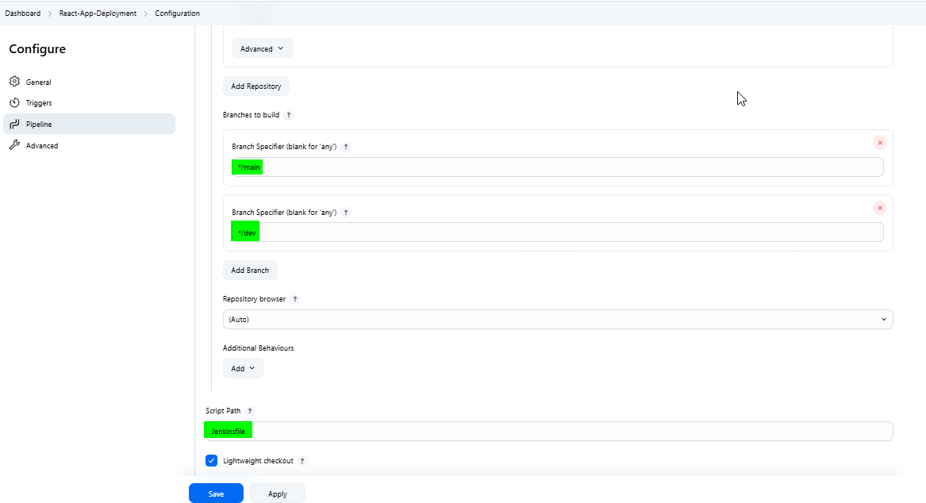

**Node configuration:**

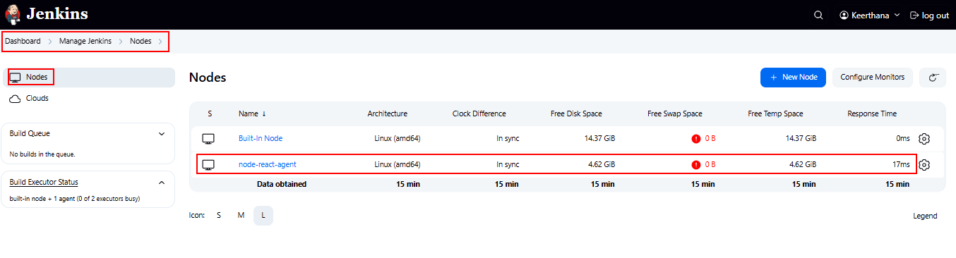

**Execute step commands – Console output**

**Console Output - dev branch**

* [Console Output - dev branch #22.txt](Console%20Output%20-%20dev%20branch%20#22.txt)

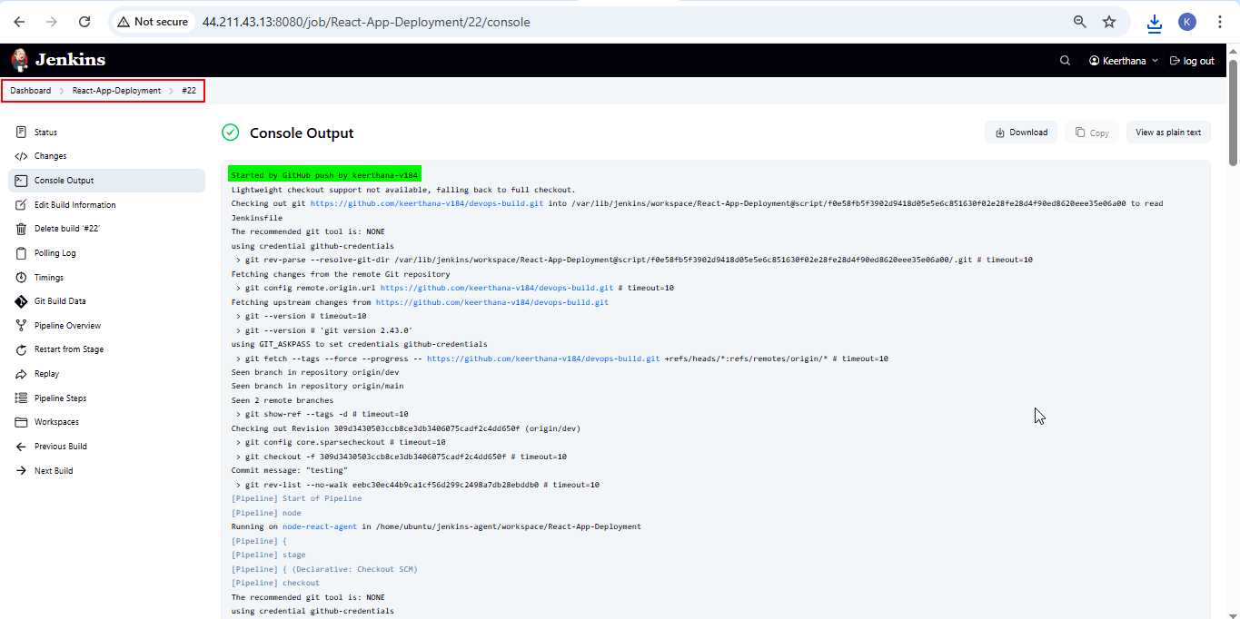  
  
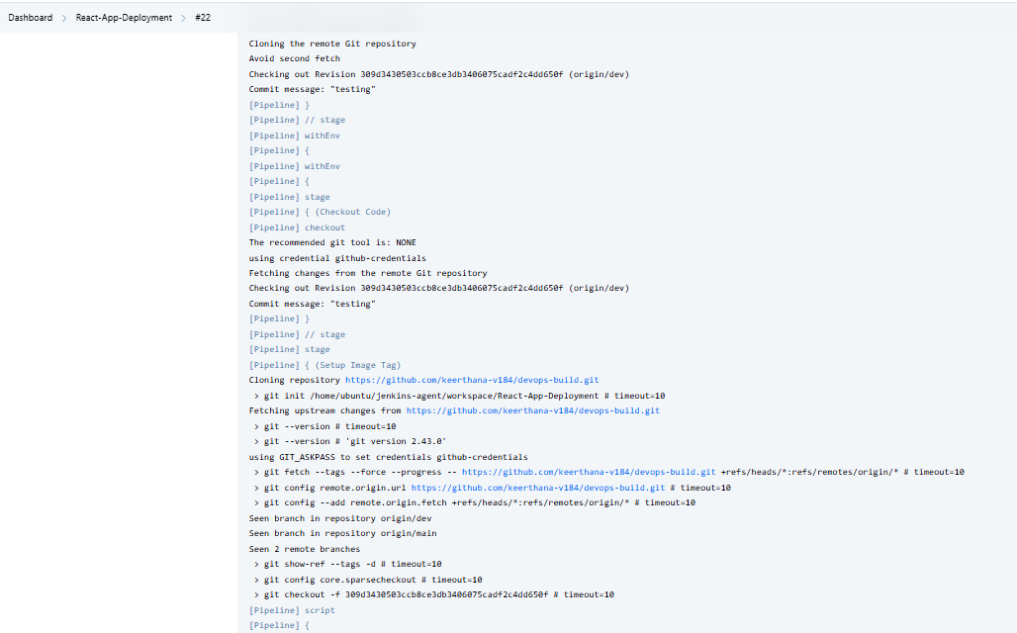  
  
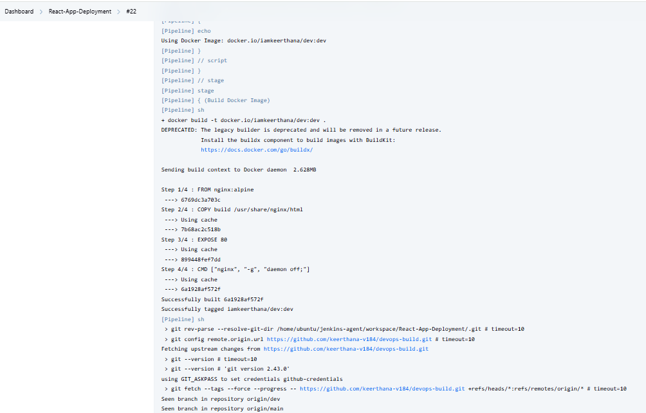  
  
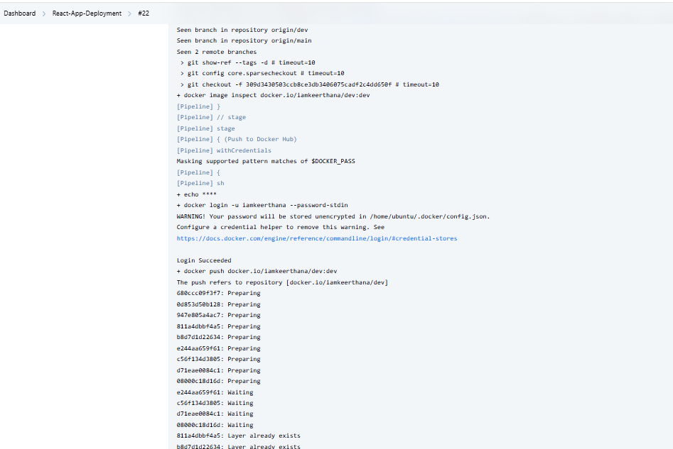  
  
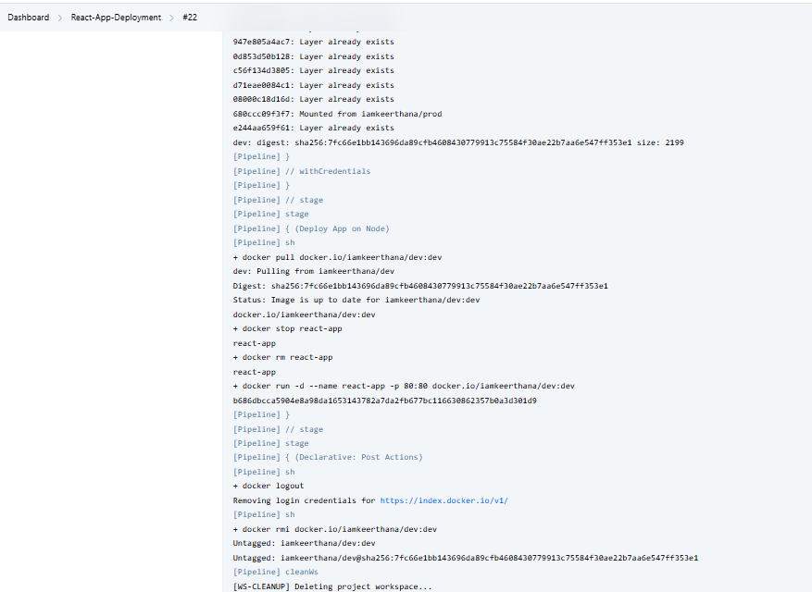  
  
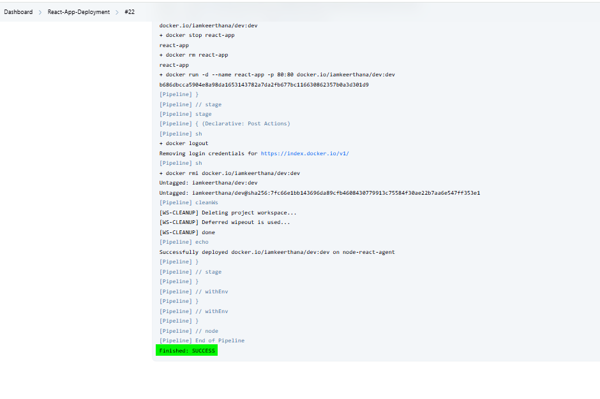

**Pipeline Overview:  
  
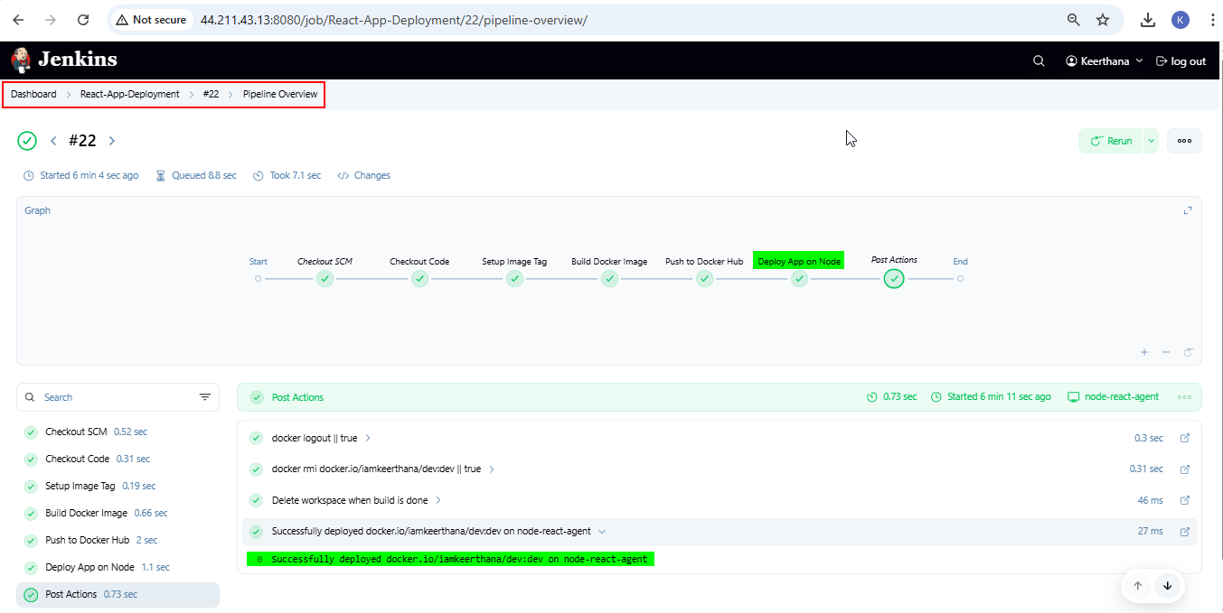**

**Console Output – main branch**

* [Console Output - main branch #23.txt](Console%20Output%20-%20main%20branch%20#23.txt)

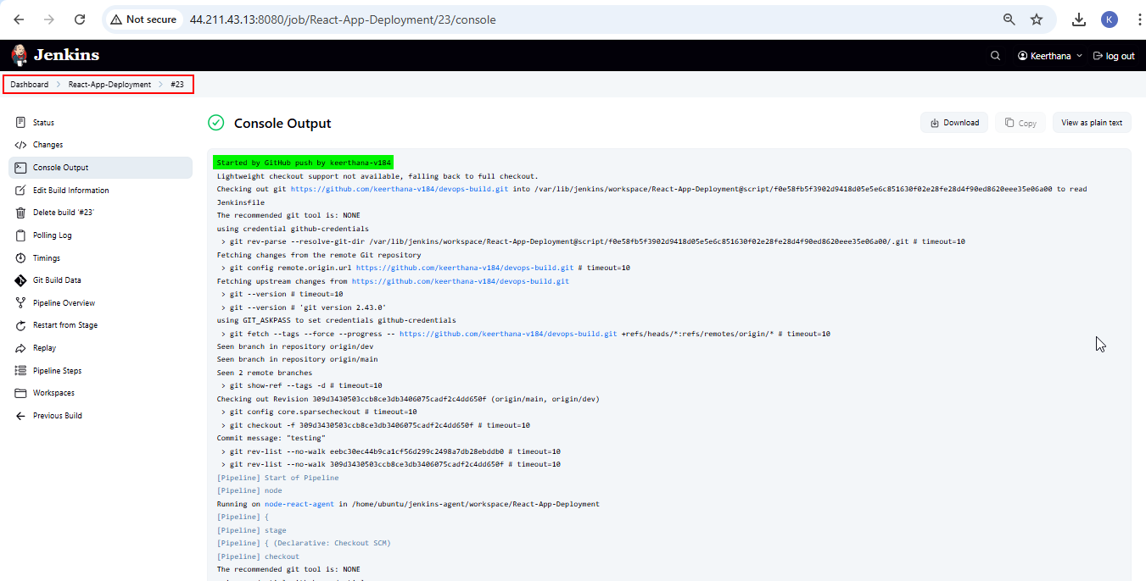  
  
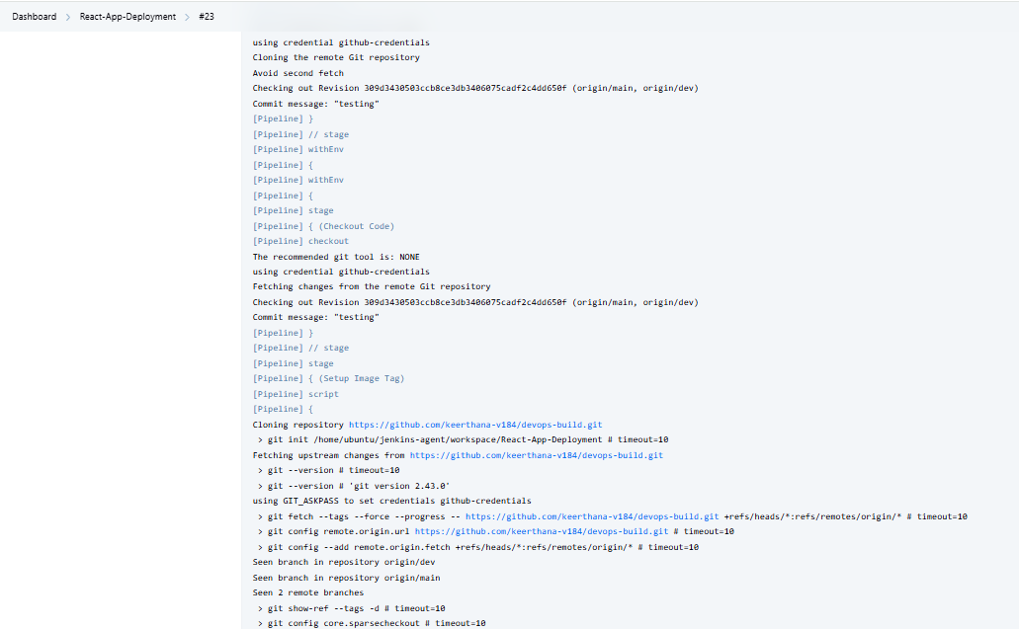  
  
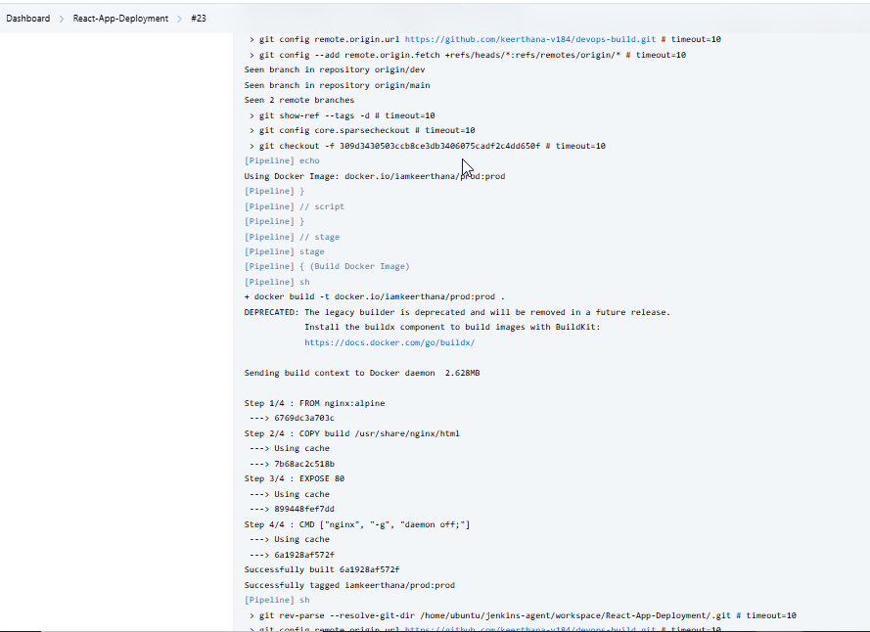  
  
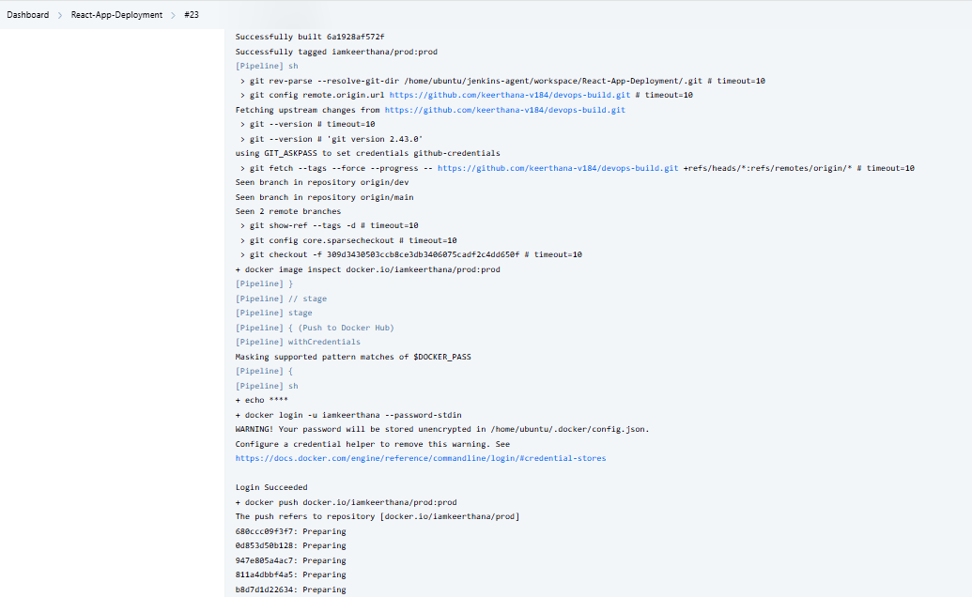  
  
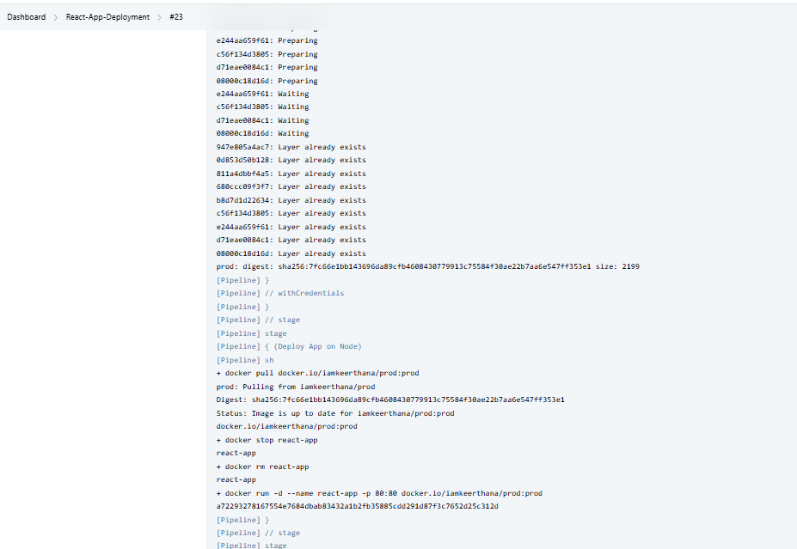  
  
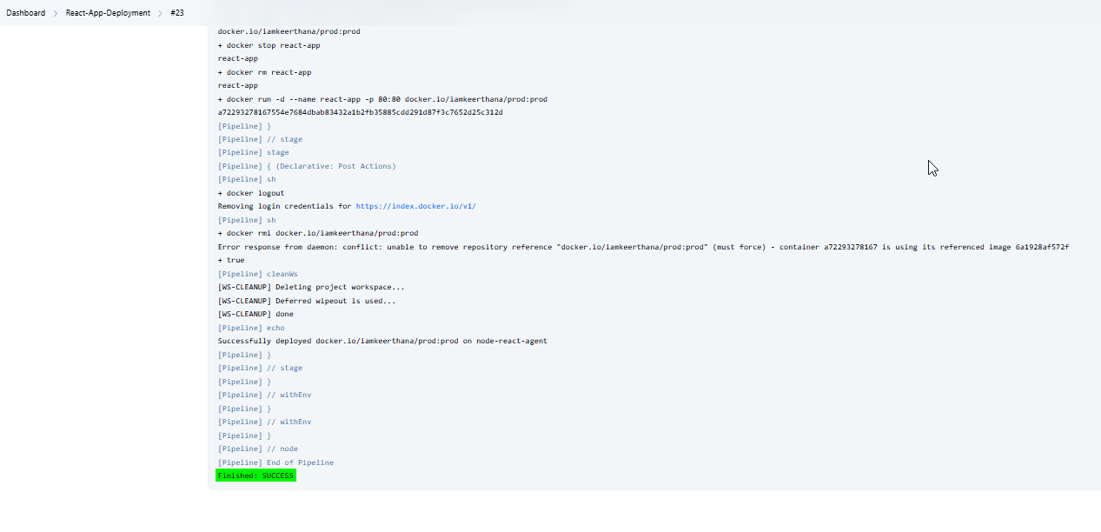

**Pipeline Overview:**

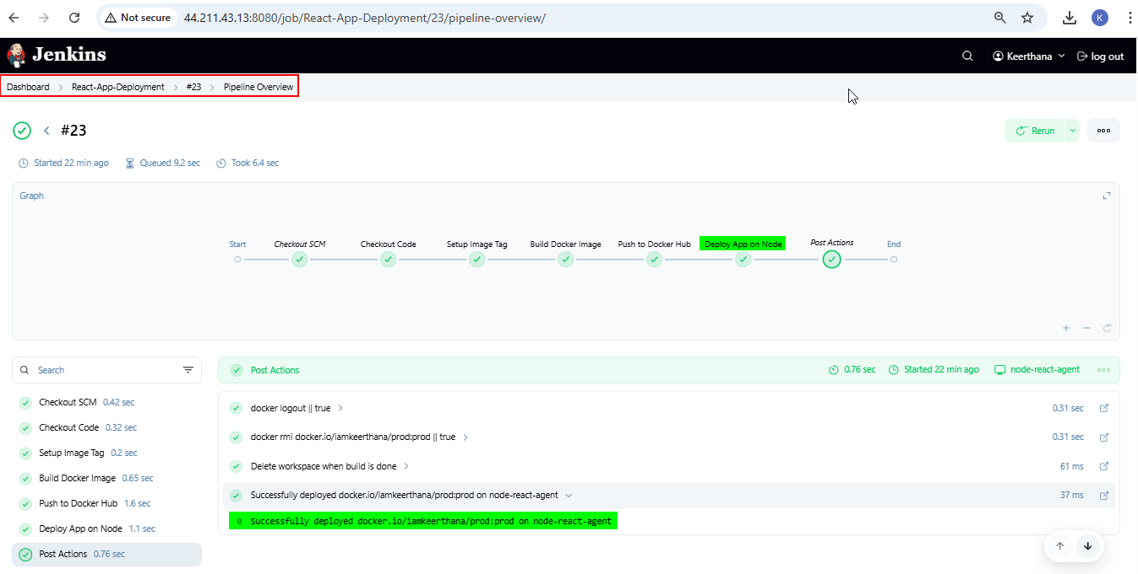

**AWS EC2-Console and SG configs**

**Jenkins-Master Instance:**

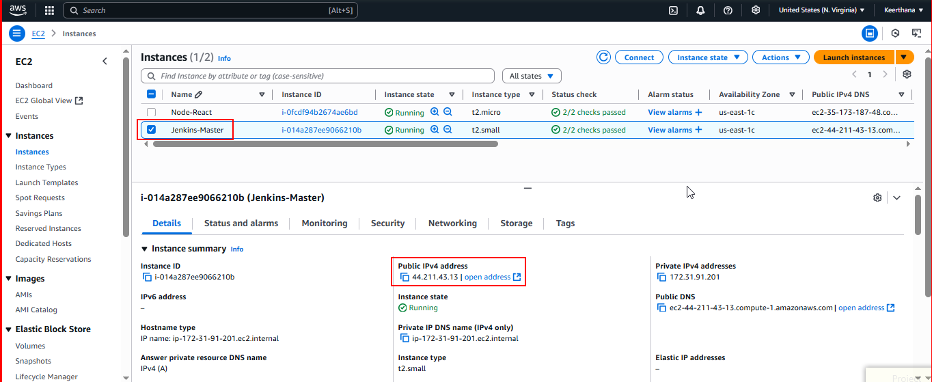

**Jenkins-Master - Security Group**

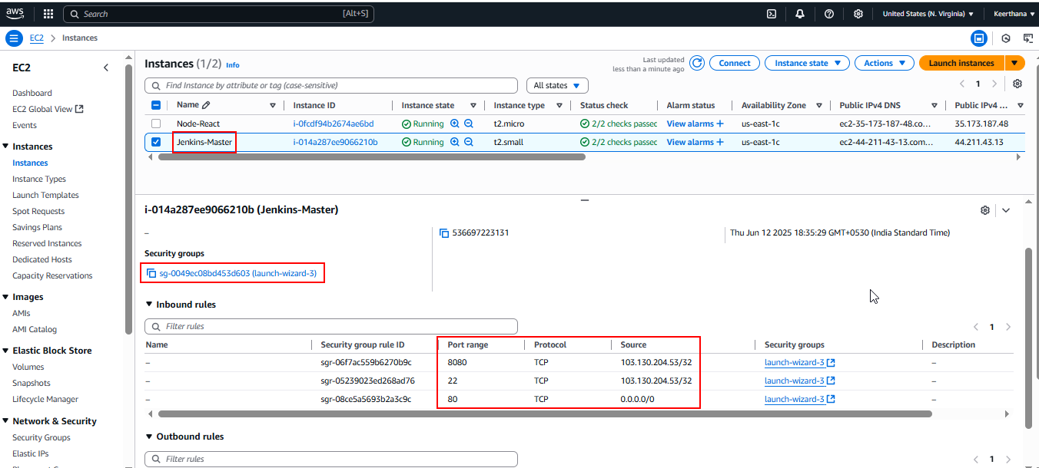

**Node-React Instance:**

* This machine is for deploying the application and working as a agent.
* Monitor the deployed react application in this instance.

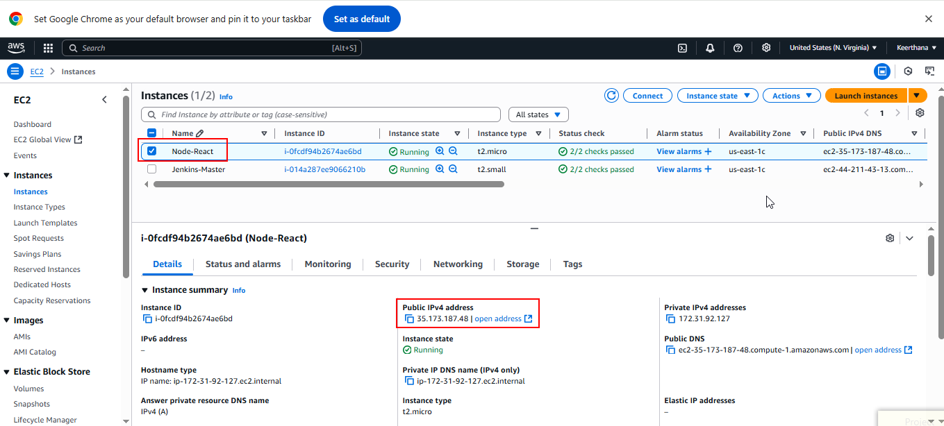

**Node-React – Security Group**

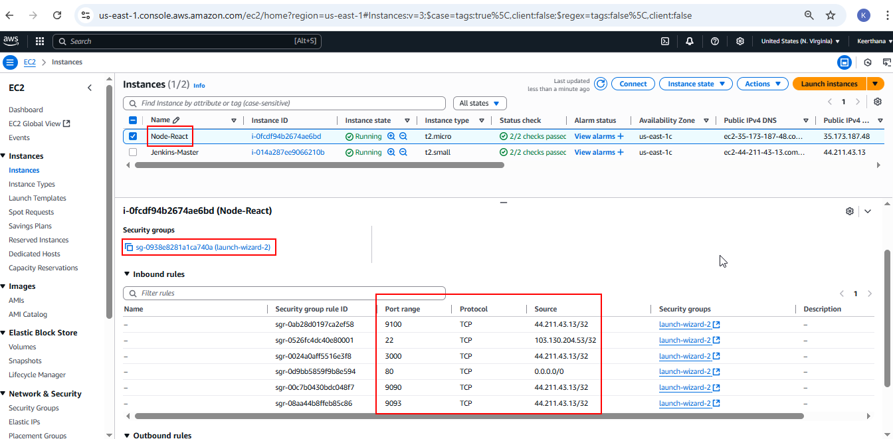

**Docker hub repo with image tags:**

**Public repo – dev repo (dev branch)**

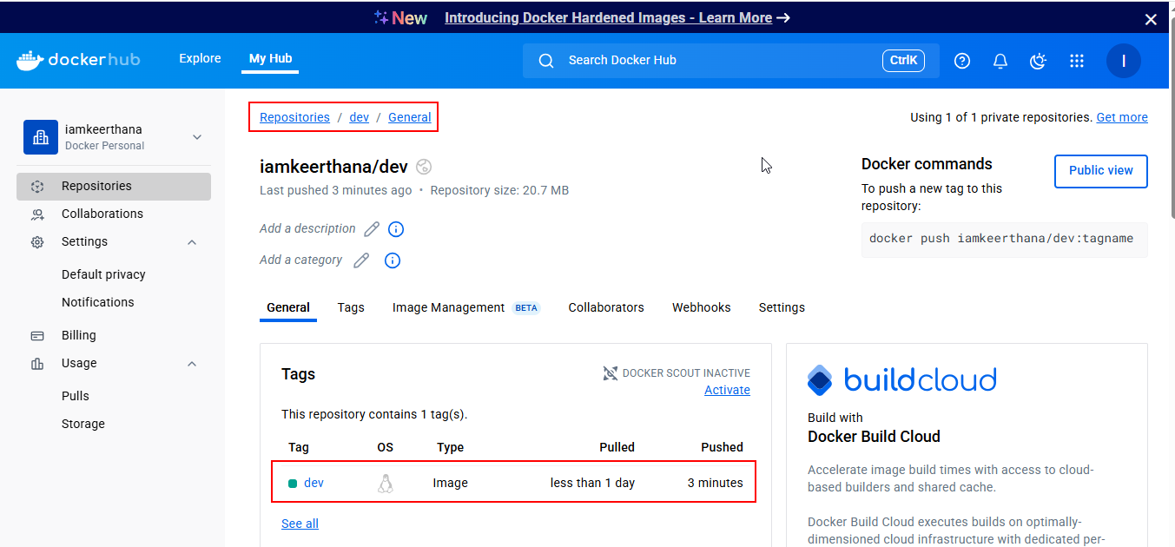

**Private repo – prod repo (main branch)**

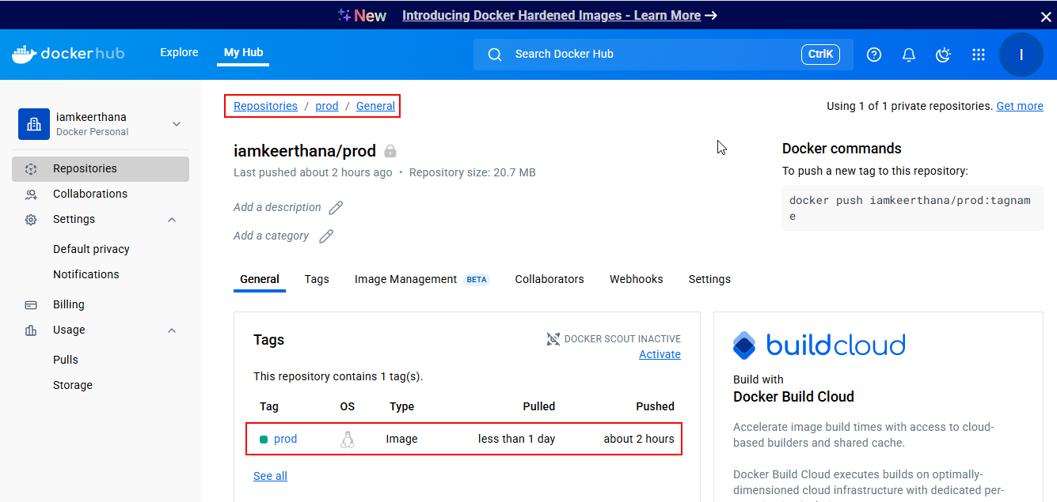

**Deployed Site Page**

* React Application deployed on Node-React instance
* Deployed Site URL - <http://35.173.187.48>

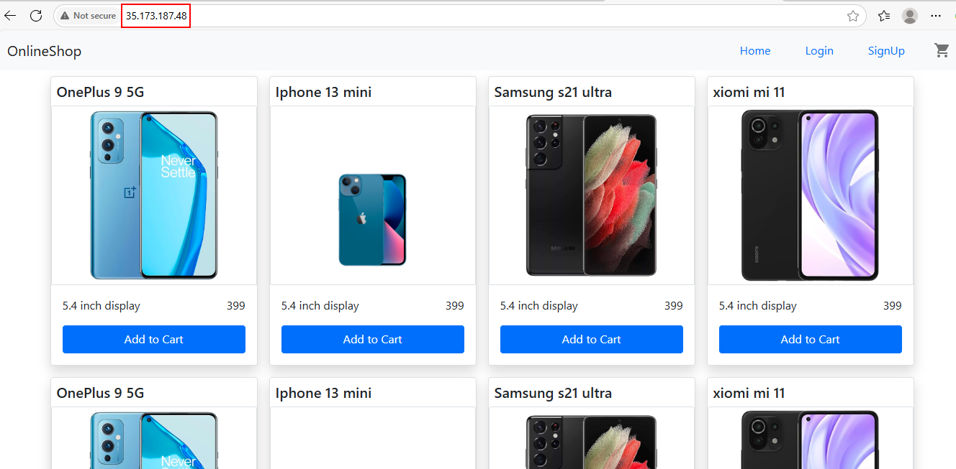

**Monitoring health check status**

**Health Check in Prometheus Tools**

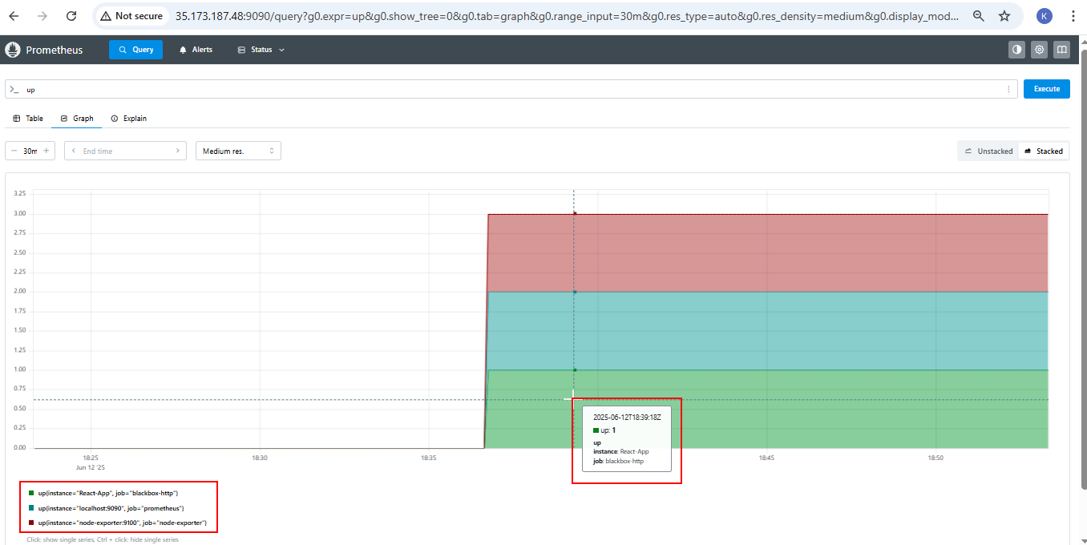

**All Metric Dashboard in Grafana:**

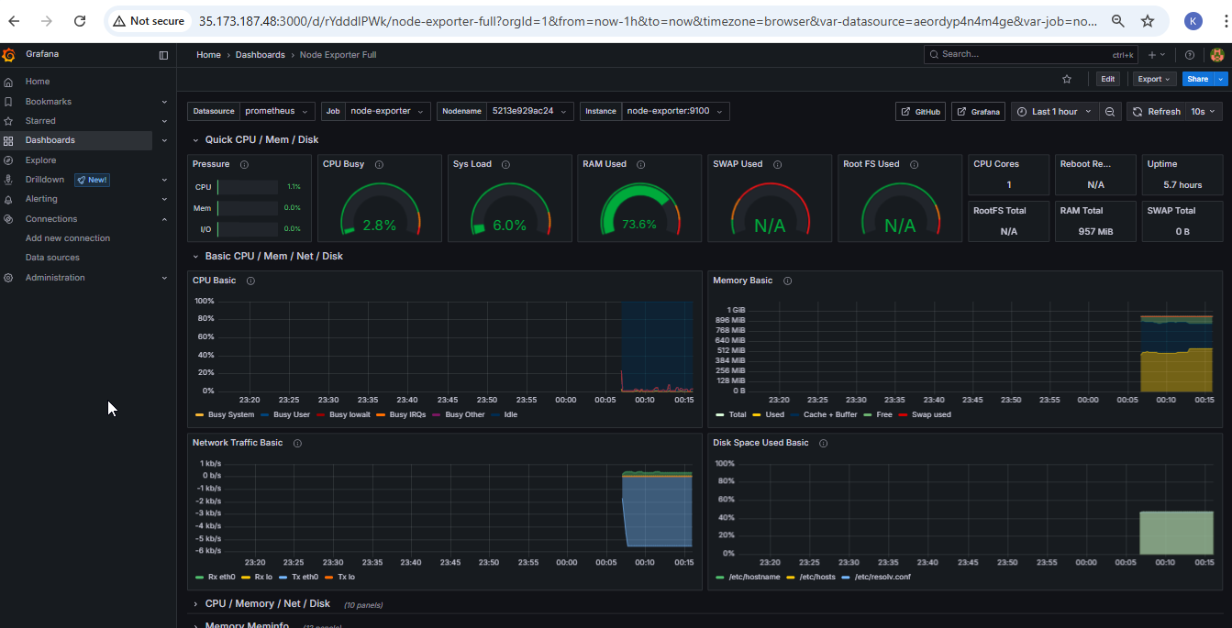

**React-Application Status – UP**

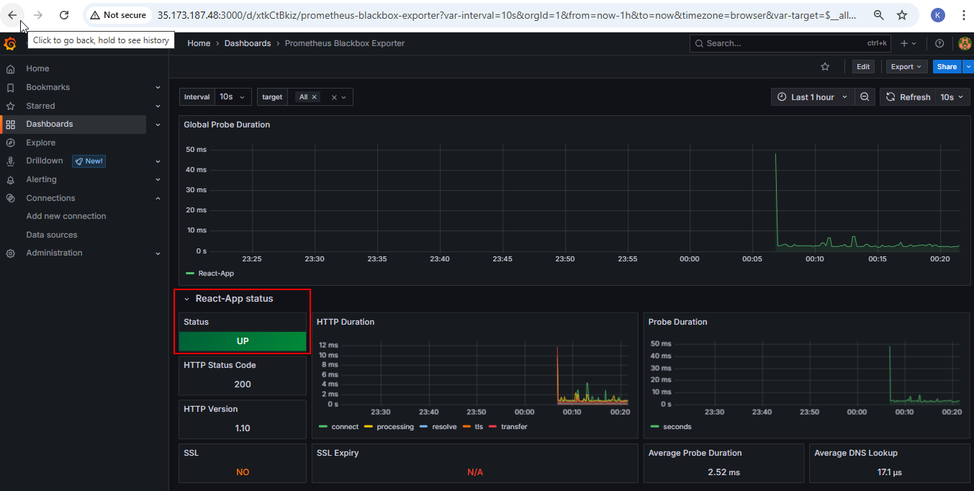

**Manually Stopped the React-App running container to check the Alert:**

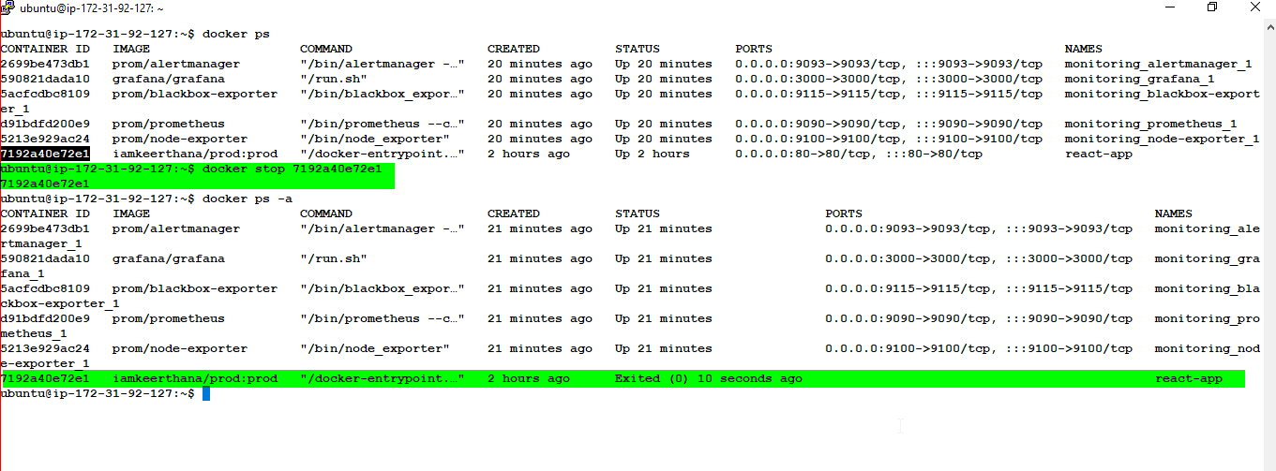

**React-Application Status - DOWN**

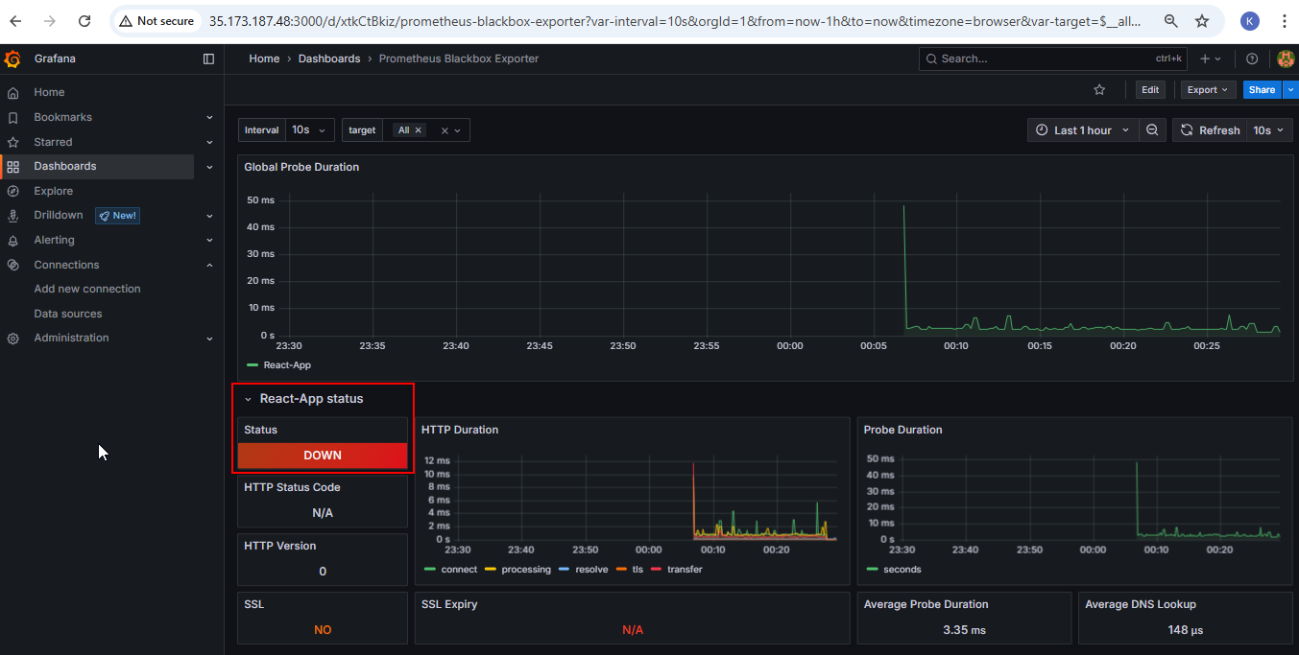

**Email Alert received when Application container goes down:**

